

A User's Guide to the Central Portal of the Biosafety Clearing-House
“Surfing the BCH Central Portal”

April 2008

Reproduction
The content of this publication may be reproduced in whole or in part and in any form for educational or non-profit purposes without special permission from the copyright holder, provided acknowledgment of the source is made. UNEP would appreciate receiving a copy of any publication that uses this publication as a source. No use of this publication may be made for resale or any other commercial purpose whatsoever without prior permission in writing from UNEP. The use of information from this website concerning proprietary products for publicity or advertising is not permitted.

Disclaimers
The content and views expressed on this website do not necessarily reflect the views or policies of the contributory organizations or the United Nations Environment Program (UNEP) and neither do they imply any endorsement. The designations employed and the presentation of material on this website do not imply the expression of any opinion whatsoever on the part of UNEP concerning the legal status of any country, territory or city or its authorities, or concerning the delimitation of its frontiers and boundaries. Mention of a commercial company or product in this publication does not imply the endorsement of UNEP.
Module Outline

1 Introduction to the module 5
2 Home Page 5
2.1 Welcome to the BCH Central Portal 6
2.2 The Management Centre 7
2.3 Latest News 8
2.4 Latest Additions 8
3 The Navigation Bar 10
3.1 The “Country Profiles” 11
3.2 The BCH 12
3.2.1 The BCH 13
3.2.1.1 Modalities of Operation 13
3.2.1.2 Multi-year Program of Work 13
3.2.1.3 Decisions on the BCH 14
3.2.1.4 Development of the BCH 14
3.2.1.5 BCH-IAC 15
3.2.2 Highlights 16
3.2.2.1 BCH News 16
3.2.2.2 Latest Additions 17
3.2.2.3 Notifications 18
3.2.2.4 Meetings and Documents 19
3.2.3 Policies 20
3.2.3.1 Linking External Websites Policy 20
3.2.3.2 Privacy Policy 21
3.2.3.3 Disclaimer 21
3.3 The Protocol 22
3.3.1 Text of the Protocol 23
3.3.2 Parties to the Protocol 23
3.3.3 COP-MOP Decisions 24
3.3.4 Reporting 25
3.3.4.1 National Reports 26
3.3.4.2 BCH Annual Reports 28
3.3.4.3 Roster of Experts Annual Reports 29
3.3.5 Meeting and Documents 29
3.3.6 Notifications (see 3.2.2.3) 30
3.4 Finding Information 30
3.5 Registering Information 32
3.6 Resources 33
3.6.1 Common Formats 35
3.6.2 Glossary 36
3.6.3 Thesaurus 37
3.6.4 Solutions for National Participation (Hermes and the BCH Ajax Plug-In) 40
3.6.5 Mailing List 40
3.6.6 Downloadable files 42
3.6.7 Online Conferences 43
3.6.8 Site Map 43
3.7 Help 44
3.7.1 FAQ 45
3.7.2 Training Modules 47
3.7.3 Guide to the BCH 48
3.7.4 Training Site of the BCH 49
3.7.5 Interoperability Services 50
3.8 Managing Search Results 51
3.8.1 Sorting results 51
3.8.2 Exporting results to XML 53

- Introduction to the module

What the user will learn in this module:
- To navigate the BCH’s Central Portal.
- To understand the main functionalities of the Central Portal.
- To know what information the user can find in the Central Portal.
- To search the databases available on the Central Portal.

Context:

The UNEP-GEF Project for Capacity Building for Effective Participation in the Biosafety Clearing-House (BCH) has prepared a modular training package that aims to provide a practical “how-to” guide for countries to assist them in learning, understanding, using, and setting-up national access to the BCH’s Central Portal. The training package is designed to be flexible and is tailored to meet diverse needs of different countries, allowing them to select those tools and ideas that are most useful to their situation, needs and priorities. The training package is divided into five modules, each addressing one element of the BCH’s Central Portal.

Audience:

This module is designed to provide guidance to users of the BCH Central Portal. It is developed for a non-technical audience with little or no knowledge of the Protocol and the BCH, but with a need to understand the requirements of the BCH Central Portal.

Purpose:

This module describes the main functions and information that can be found on the BCH Central Portal. Users will learn how to navigate the BCH Central Portal, knowing:
- The structure of information available on the BCH Central Portal;
- The different categories of information found on the BCH Central Portal.

Note that while users are connected to the BCH Central Portal (http://bch.cbd.int/) they can read the sections of this module and surf its various components.

- Home Page

URL: http://bch.cbd.int/

The Home page of the BCH Central Portal is a Welcome page that provides a gateway to each element of the BCH and all data stored in the Central Portal as well as in the international, regional and national nodes linked to the BCH.

The seven components of the Home page are:

- Links to the BCH in all six United Nations (UN) official languages are provided in the top left corner of the Home page.
- A Sign In link for registered users (to access the management centre) and a link to Sign up for an Account (for new users to request a BCH account) are positioned in the top right corner.
- Below these links is the title for the Biosafety Clearing-House and a link in the centre to the website for the Convention on Biological Diversity.
- A navigation bar runs across the Home page below the title. It provides links to the main components of the Central Portal.
- Below the navigation bar, there is a welcome area containing Latest News and Latest Additions;
- To the right of the welcome area there are shortcuts to popular or recently added sections.
- Below the welcome area there are links for users to contact the CBD Secretariat, access the site map, review the linkages and privacy policies and review the copyright statement. Below these links is the date of the last update of the Home page and a link to enable users to rate this page.
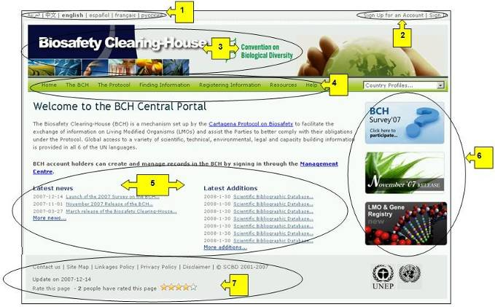
Figure 1

  - Welcome to the BCH Central Portal

The Welcome to the BCH Central Portal page of the BCH Central Portal has a welcome area that briefly introduces the BCH, provides a quick link to the Management Centre and provides information about highlights, such as the latest news about the BCH Central Portal and the most recent additions to the databases.
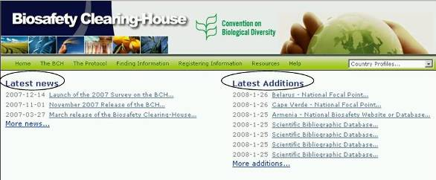
Figure 2

  - The Management Centre
Immediately below the BCH introductory paragraph is a link to the Management Centre, an entry page for BCH account-holders to create and manage their records registered in the BCH.

Module MO06 provides detailed guidance on how to register information in the BCH.
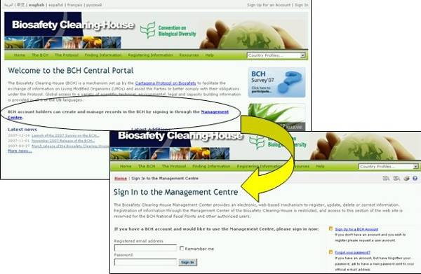
Figure 3

  - Latest News

The news links posted in this area provide details of new processes and facilities in the Central Portal. A complete list of BCH news is available at https://bch.cbd.int/news/news.shtml and can be reached by following the link to More news.

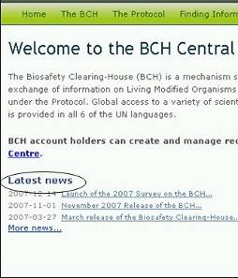
Figure 4

  - Latest Additions

The most recent additions to the BCH databases are displayed on this list. The list is updated every six hours and the seven most recent entries show on the Home page. A complete list of BCH additions is available at https://bch.cbd.int/about/latestadditions.shtml and can be reached by following the link to More additions.

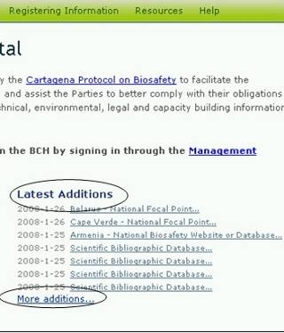
Figure 5

In many instances the Search results pages are longer than a standard computer screen and the user needs to scroll down the page to view all the items and links to additional search result pages where these exist.

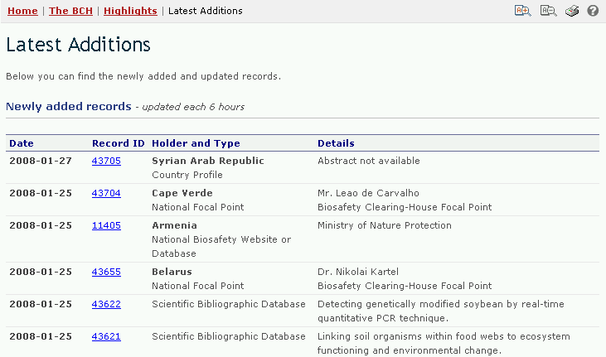
Figure 6

- The Navigation Bar

Above the welcome area of the Home page is a navigation bar that provides links to the major components of the BCH.
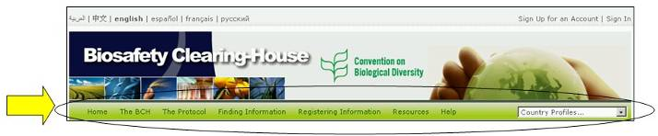
Figure 7

The BCH section provides links to information about the BCH, its development and management, highlights and policies.

The Protocol section provides links to the text of the Protocol, a list of Parties to the Protocol, COP-MOP Decisions, information about official reports, meetings documents and Notifications. The Finding Information section provides links to search interfaces for the different categories of information in the BCH databases and to compiled information (i.e. National Contacts, the LMOs Registry, the Parental Organisms Registry and the Gene Registry).

The Registering Information section links the user to the sign in page for the Management Centre through which BCH users can create and manage their information.

The Resources section provides access to other useful site resources such as (i) the Common Formats used in the BCH, (ii) the Glossary, (iii) the Thesaurus; (iv) a page describing the solutions for National Participation (Hermes and the BCH Ajax Plug-In), (v) the available Mailing Lists, (vi) a list of downloadable files and (vii) the Site map.

The Help section provides access to (i) Frequently Asked Questions (FAQ), (ii) BCH Training Modules, (iii) Guide to the BCH, (iv) Training Site of the BCH and (v) Interoperability Services. On the right side of the navigation bar is a search box for locating country profiles. This provides a quick search function to locate all records for each country listed.

The menus on the BCH Central Portal use icons to illustrate aspects of the associated links. The commonly encountered menu icons include:
Link takes the user to another website
Link to a PDF document
Link takes the user to a search facility on another website

Details of more icons used on the BCH Central Portal are provided in the Ready Reference 4 guide available on the Training Site of the BCH (https://bchtraining.cbd.int/member/training-signin.aspx?returnurl=%2fdefault.shtml).

  - The “Country Profiles”

URL: http://bch.cbd.int/

All pages of the BCH provide a quick search facility to obtain country profiles. The link is provided on the right hand side of the navigation bar. The drop down menu allows the user to select a country and display a summary of all the records entered in the BCH by that country.

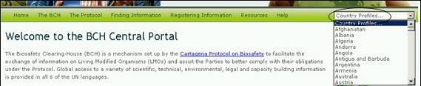
Figure 8

The country profiles contain information and status for each country as follows: Country; Date of signature; Date of ratification; Date of entry into force; Profile revision; Profile status and Profile last updated on. It lists the type of documents registered (e.g. National Focal Point, Law, regulation or guideline, risk assessment, etc.) with hyperlinks to access those records. The number of records for each type of document is indicated as well as the date of last update.

  - The BCH

URL: http://bch.cbd.int/about/

The introductory page for the BCH section explains the Mandate of the BCH and provides some background information about the development of the site. The information about the BCH is divided into three sections:

- The BCH, setting out its Modalities of Operation, Multi-year Program of Work, Decisions on the BCH, Development of the BCH and the BCH Informal Advisory Committee (BCH-IAC);
- Highlights, providing BCH News, Latest Additions, Notifications and Meetings and Documents;
- Policies, providing information about Linking of External Websites Policy, Privacy Policy and Disclaimer.
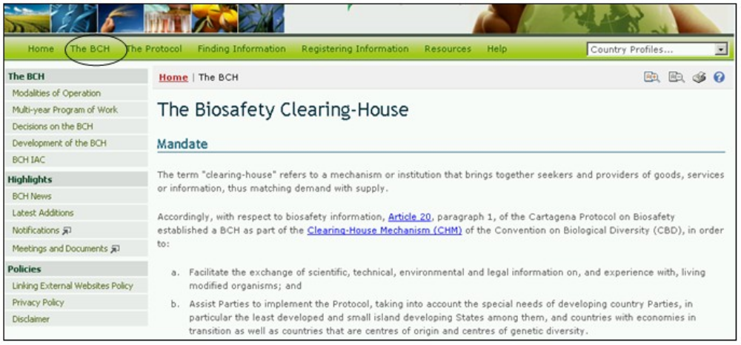
Figure 9

The content of the BCH section is accessed from the menu on the left side of The Biosafety Clearing-House page, or from The BCH drop down menu on the navigation bar.
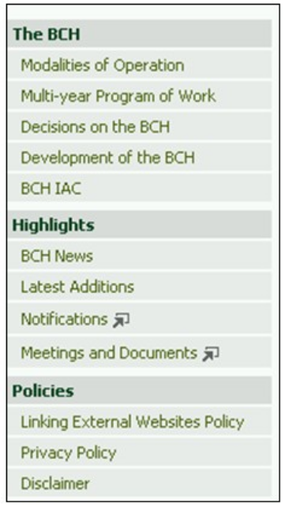
Figure 10

    - The BCH

This section provides information about the establishment and running of the BCH Central Portal.

Modalities of Operation

The link for Modalities of Operation takes the user to a page which provides information about how the BCH functions and the roles of the institutions that participate in its establishment, maintenance and use.

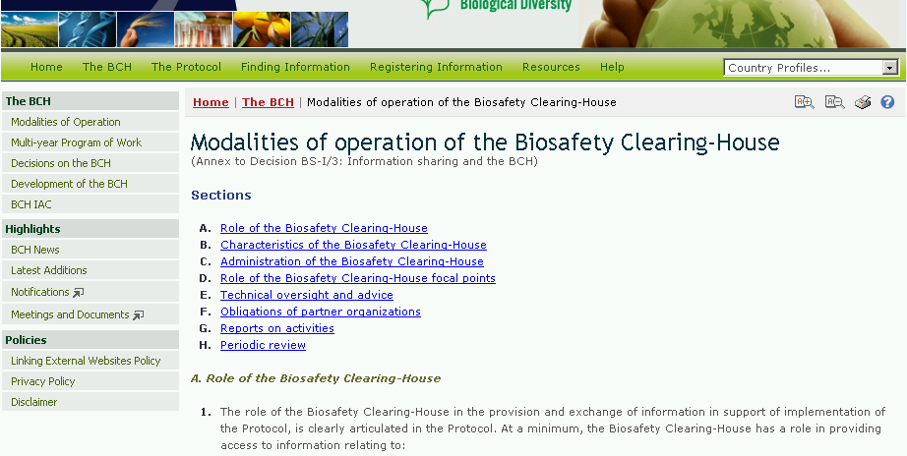
Figure 11

Multi-year Program of Work

The link for the Multi-year Program of Work takes the user to a page which outlines the establishment and maintenance of the major components of the BCH.
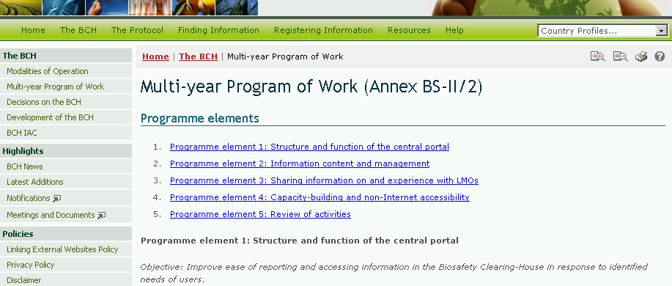
Figure 12

The Multi-year Program of Work page provides information about the objectives and possible activities for each program element as decided by COP-MOP.

Decisions on the BCH

The link for Decisions on the BCH takes the user to a page which provides links to all BCH decisions taken by COP-MOP as well as at ICCP meetings before the entry into force of the Cartagena Protocol.
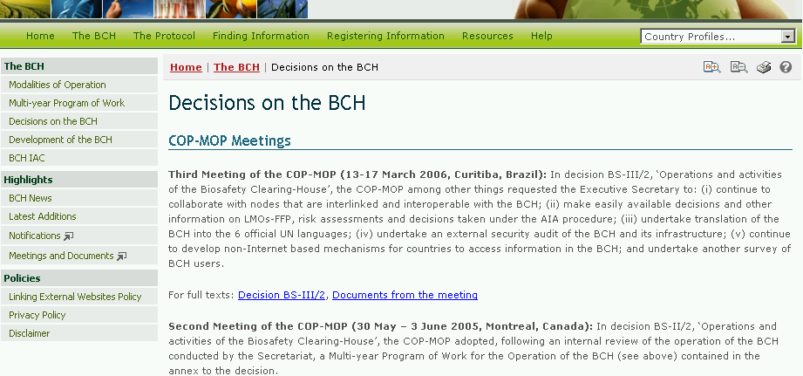
Figure 13

Development of the BCH

The link for Development of the BCH takes the user to a page which provides information about stages of development of the BCH from 2003 to the present. Each entry has a link to a notification document detailing the developmental milestones. For example, the 2006 notification of the offline version of the BCH (Notification 2006-124) shown here.
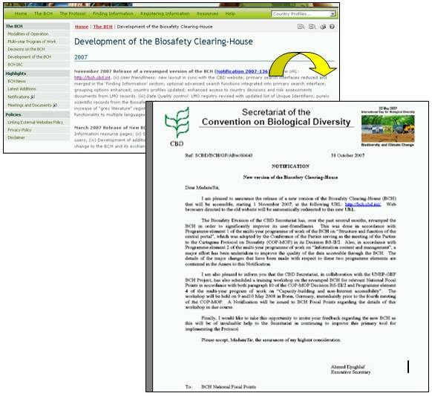
Figure 14

BCH-IAC

The link for BCH-IAC takes the user to the BCH Informal Advisory Committee.

The BCH Informal Advisory Committee provides guidance to the Executive Secretary with respect to resolution of technical issues associated with the ongoing development of the Biosafety Clearing-House. The BCH-IAC page provides information about IAC the meeting documents and summaries of the outcomes of each meeting.
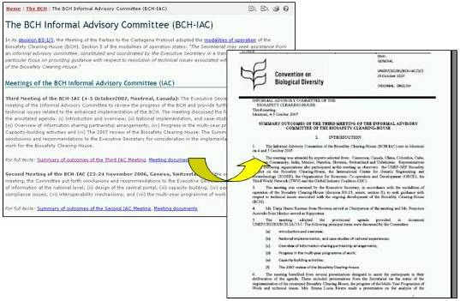
Figure 15

    - Highlights

The section of the BCH Central Portal provides links to information that highlights the activities of the BCH.

BCH News

BCH News links the user to the Latest News section. It provides updates on changes to the BCH Central Portal. Registered users can register BCH news from this page by using the Submit news button.
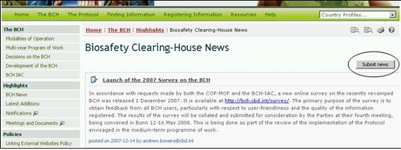
Figure 16

At the bottom right of the Biosafety Clearing-House News page is a Subscribe to the Rss feed button, Rss that takes the user to the RSS News Items page. This page briefly describes the function of the feeds, provides a link to Learn more about feeds and provides a link to Subscribe to this feed.
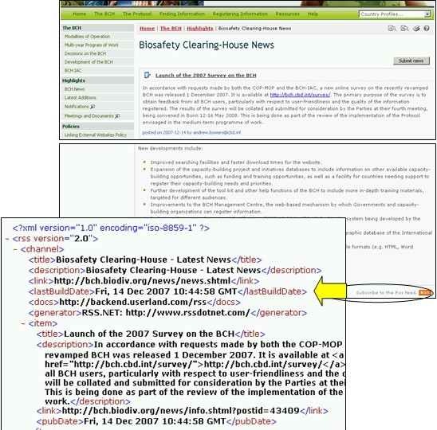
Figure 17

Latest Additions

Latest Additions links the user to a page that displays the most recent additions to the databases. The information is updated every six hours.

Selecting a Record ID takes the user to the record page.
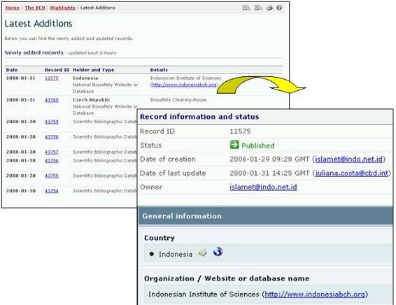
Figure 18

Notifications

The Notifications link takes the user to a page with a search interface that can be used to find notifications issued by the CBD Secretariat. To search Notifications filed under the Protocol, select Cartagena Protocol on Biosafety from the Subject Box drop down menu and, where possible, refine the search with a word from the title of the document or the year the document was published. Click the Go button to obtain the search results. If the Notification Reference number is known, it can be entered into the ‘reference’ field and the Notification will be retrieved by clicking the Go button.

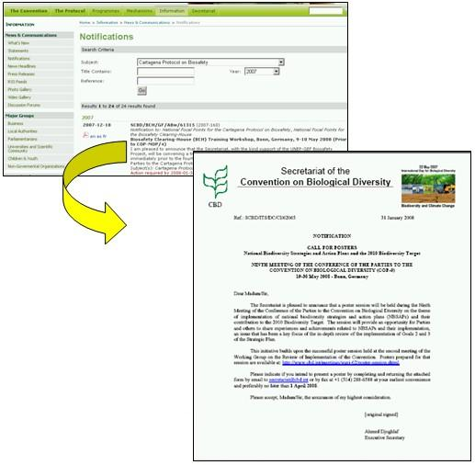
Figure 19

Meetings and Documents

The Meetings and Documents link takes the user to the Calendar of SCBD Meetings page where a list of upcoming meetings related to the Cartagena Protocol on Biosafety can be accessed.

The search for meetings and documents can be refined by selecting specific search parameters such as country, year, month and words from the title.
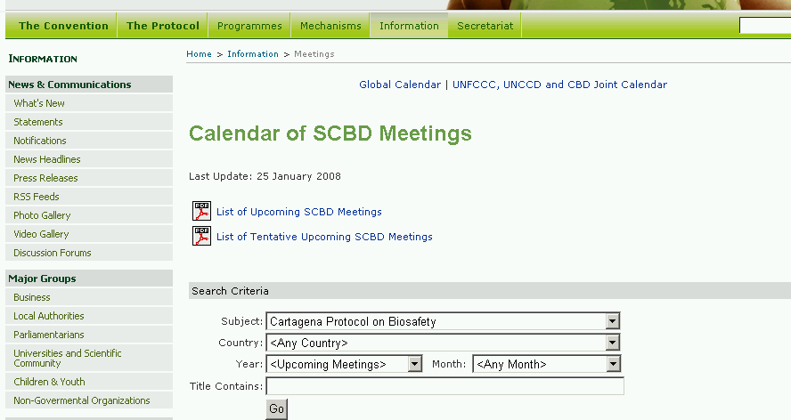
Figure 20

    - Policies

The section on Policies provides links to information about the linking of external websites to the BCH, the privacy policy of the BCH and a disclaimer.
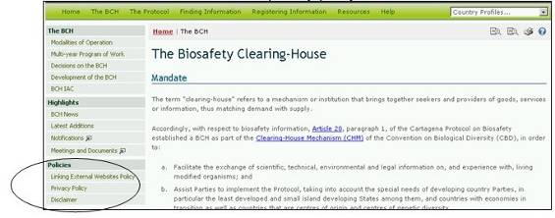
Figure 21

Linking External Websites Policy

The link for Linking External Websites Policy takes the user to a page which details how the Secretariat considers and selects sites for inclusion in the BCH Central Portal.
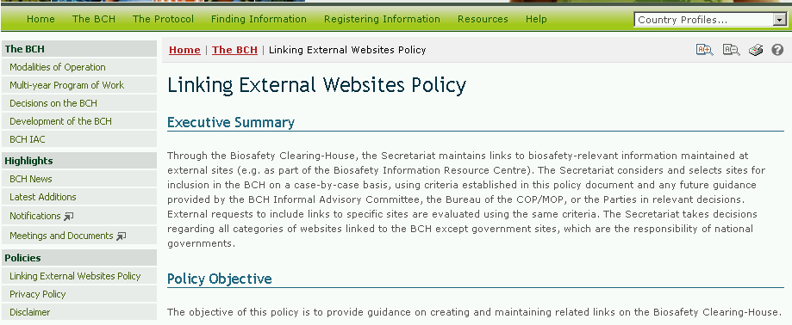
Figure 22

Privacy Policy

The link to Privacy Policy takes the user to a page which details how information submitted to the BCH is handled and how the BCH manages information about visitors to the BCH Central Portal.
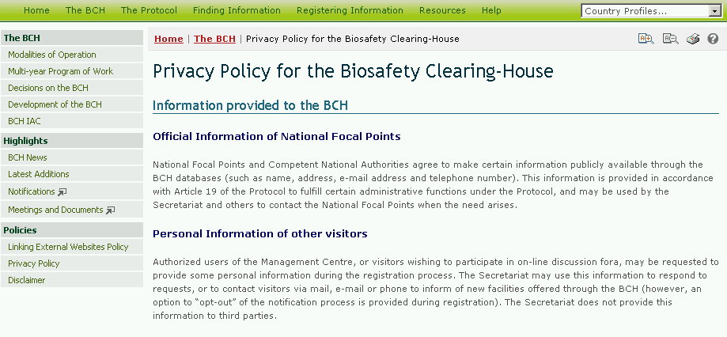
Figure 23

Disclaimer

The link to Disclaimer takes the user to a page which notes that while every effort is made to provide accurate information, the accuracy of the information provided through the BCH is not guaranteed. Parties to the Convention, Governments and other users of the database are encouraged to bring errors, inaccuracies and omissions to the attention of the Secretariat.
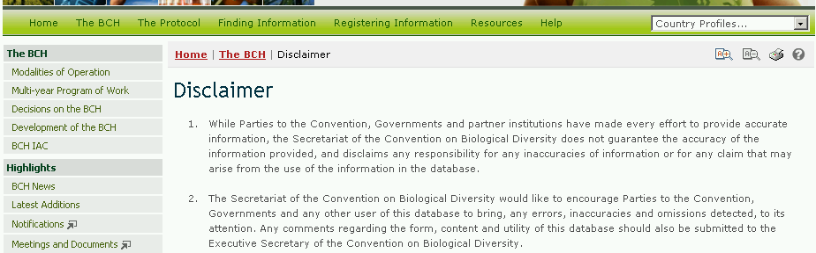
Figure 24

  - The Protocol

URL: http://bch.cbd.int/protocol/

The Protocol link on the navigation bar provides access to information about the Cartagena Protocol on Biosafety.

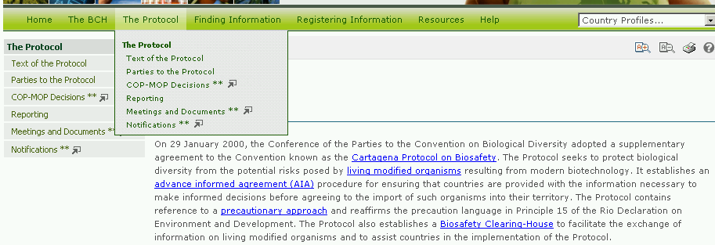
Figure 25

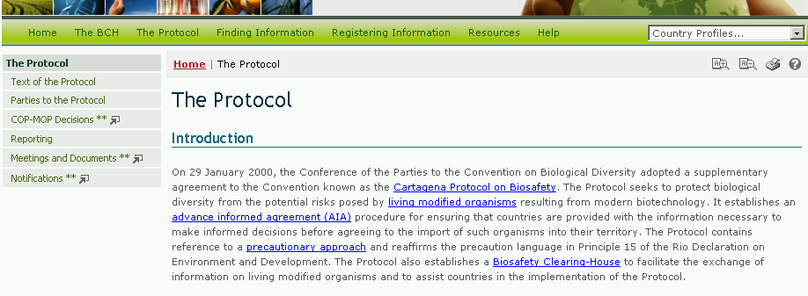
Figure 26

The Protocol page is divided into four sections that provide:

- A brief introduction to the Protocol;
- A short history of the development of the Protocol;
- An explanation of the ICCP process; and
- Related links to COP decisions, meetings of the Open-ended Ad Hoc Working Group on Biosafety and relevant publications.

The left hand menu on The Protocol page provides information in six areas:

- Text of the Protocol;
- Parties to the Protocol;
- COP-MOP decisions;
- Reporting;
- Meeting and Documents;
- Notifications.

    - Text of the Protocol

The link for Text of the Protocol takes the user to a page which provides links to the complete text of the Cartagena Protocol on Biosafety in the six official United Nations languages and in both MS Word and PDF format. Links are also provided to web pages reporting the text of each article of the Protocol.
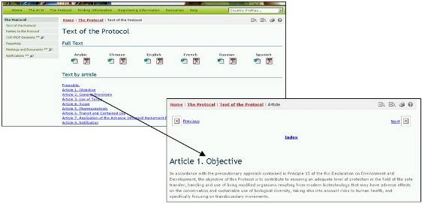
Figure 27

    - Parties to the Protocol

The link for Parties to the Protocol takes the user to a page which provides a summary of the status of ratification and entry into force for each Party of the Protocol. The table lists countries that have signed, ratified, accepted, approved or acceded to the Protocol and the date at which the Protocol entered into force in each country. Each country name provides a link to the Country Profile which provides summary information about all records registered in the BCH by that country.

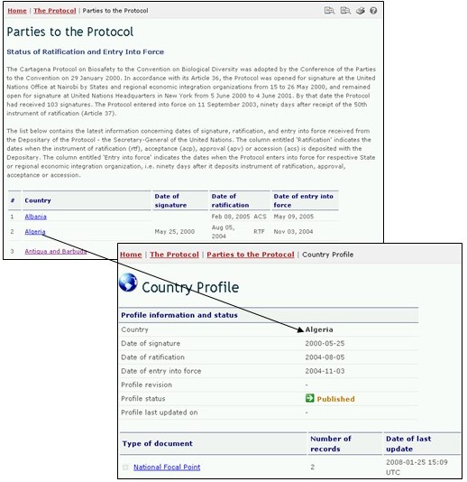
Figure 28

    - COP-MOP Decisions

The link for COP-MOP Decisions takes the user to a page with a search interface for finding all decisions taken at all COP-MOP meetings.

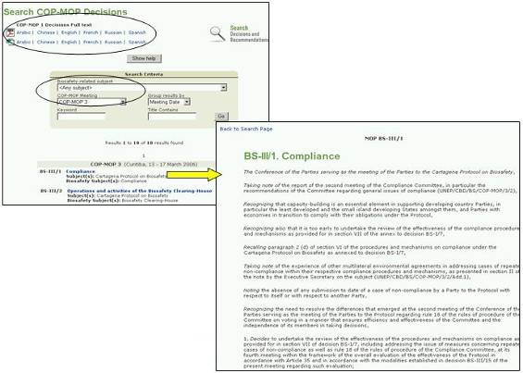
Figure 29
The search criteria include biosafety-related subjects; a choice of COP-MOP meeting; keywords; or words in the title. The results can be grouped by meeting date or meeting group.
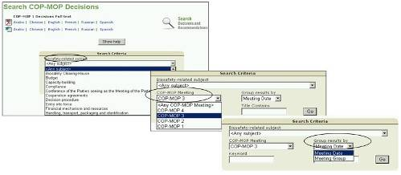
Figure 30

    - Reporting

The Reporting link takes users to a page that provides links to

- National Reports.
- Annual Reports of the operation of the BCH.
- Annual Reports of the operation of the Roster of Experts.

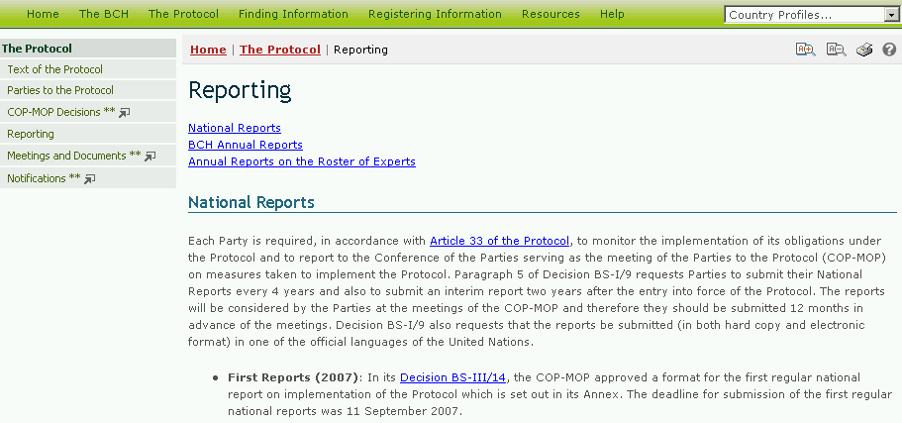
Figure 31

National Reports

In the National Reports section of the Reporting page, national reports on the implementation of the Protocol can be accessed by selecting a country from the drop down menu in the text.
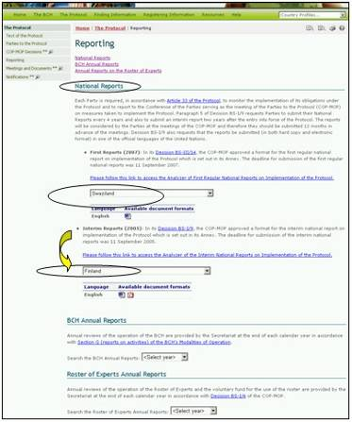
Figure 32

This section also provides links to the National Reports Analyzer. This is an electronic facility which is intended to assist users to aggregate and analyse data according to selected Parties, geographic areas, economic groups and other criteria.

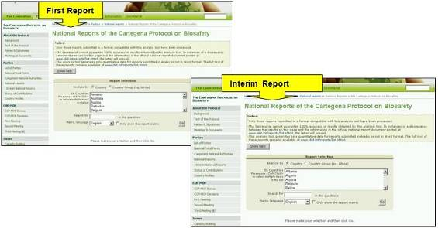
Figure 33

On the Analyzer, the user can refine the search using known words in the questions or selecting the matrix languages used for the analyses. Selecting the Go button calls up the search results. These are tabled below the search facility.

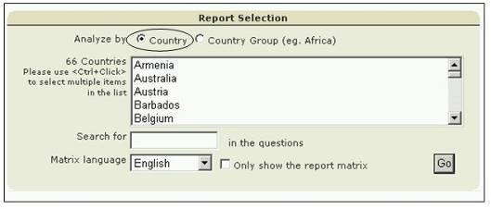
Figure 34

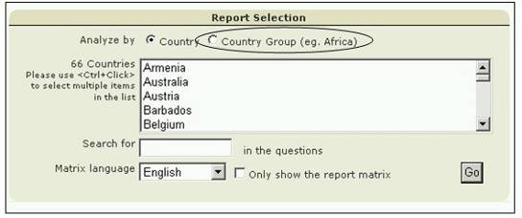
Figure 35

BCH Annual Reports

The BCH Annual Reports cover the operation of the BCH and are provided by the Secretariat at the end of each calendar year. These reports can be accessed by selecting the year of interest in the search box. Selecting a year in the search box takes the user to the relevant Annual Report page which provides the text of the report.

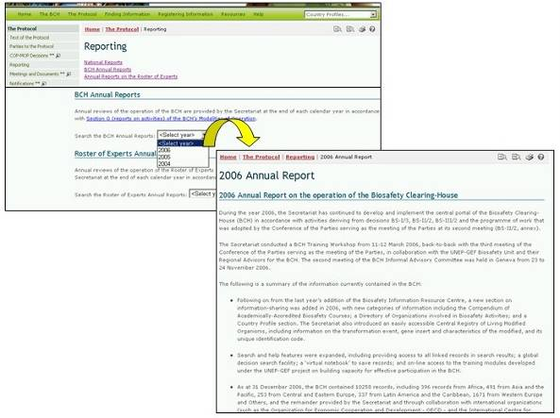
Figure 36

Roster of Experts Annual Reports

The Roster of Experts Annual Reports are provided each calendar year by the Secretariat and report on the operation of the Roster of Experts as well as the voluntary fund for the use of the roster.

By using the drop down menu available in this section, it is possible to select the year of interest and access to the copy of the report for that year (in PDF format).
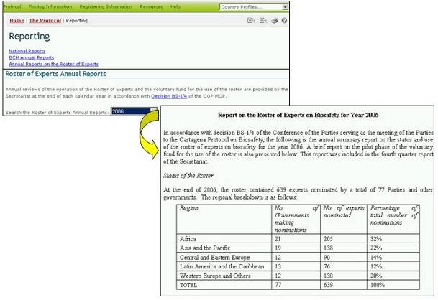
Figure 37

    - Meeting and Documents

The link to Meetings and Documents takes the user to the Calendar of SCBD Meetings page that provides links to PDF copies of a list of upcoming SCBD meetings and a list of tentative upcoming SCBD meetings. The date of last update of these lists is provided above these links.

The Calendar of SCBD Meetings page also provides a search facility to identify meetings related to specific aspects of the CBD.

If the user selects Cartagena Protocol on Biosafety in the Subject box and clicks on Go, a list of past, confirmed and tentative meetings is provided below the search facility. The table of search results provides links to documents for the meetings, where these are available.

The search for meetings related to the Protocol can be refined by selecting specific search parameters such as the subject of the meeting; the country that hosted or will host the meeting; year; month and words from the title.

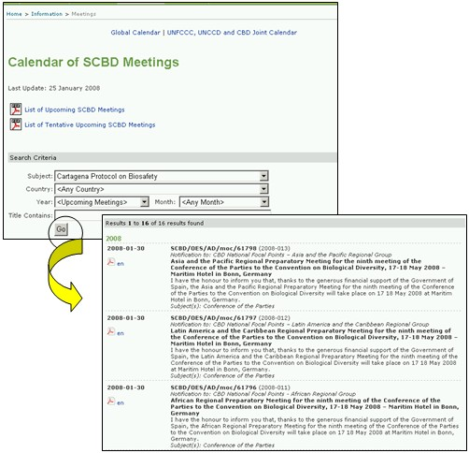
Figure 38

    - Notifications (see 3.2.2.3)

  - Finding Information

URL: http://bch.cbd.int/database/

The links to categories of information in the databases of the BCH Central Portal are provided in the Finding Information drop down menu on the navigation bar.
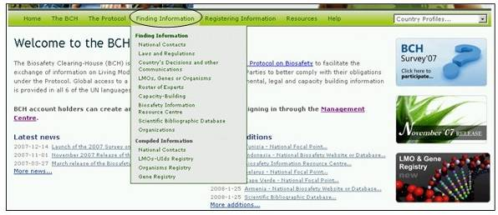
Figure 39

Each category listed on this page links to a search interface that is designed to optimize the location of specific information. From the page of the search interface it is also possible to browse all entries in any one of the categories by utilizing a ‘Browse all records’ button.
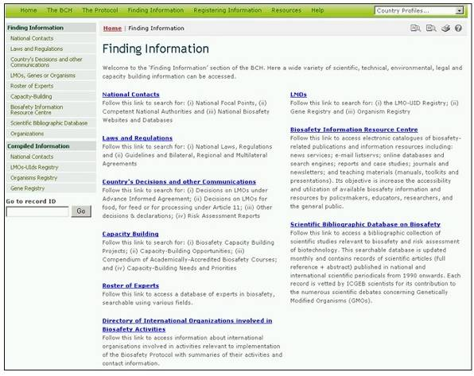
Figure 40

The types of data stored in the BCH databases and instructions for finding information are detailed in Module MO04.

  - Registering Information

URL: https://bch.cbd.int/member/signin.shtml?returnurl=%2fmanagementcentre%2fdefault.shtml

The BCH Management Center provides a web-based mechanism to register, update, delete or correct information in the BCH databases. Registration of information through the Management Center is restricted to BCH National Focal Points for information related to national implementation of the Protocol as follows:

- Biosafety Experts
- Competent National Authorities
- Country Needs and Priorities
- Decisions on LMO for FFP under Article 11
- Decisions on LMO under Advance Informed Agreement
- Laws
- National Biosafety Websites or Databases
- Other Decisions or Declarations
- Regional or International Agreement
- Regulations or Guidelines
- Reports on Biosafety Expert Assignment
- National Risk Assessment reports

The Management Centre is available to all registered users for the other categories of information in the BCH (pending validation by the SCBD) as follows:

- Biosafety Courses
- Capacity Building Projects & Opportunities
- Biosafety International Organizations
- BCH News items
- Contact Information
- General Risk Assessment reports
- LMO / Gene / Parent or Donor Organism Registries items
- Biosafety Information Resource Centre (BIRC) items

The Secretariat reserves the right to review and verify, prior to publication, all information submitted by BCH registered users. Contributions to the Scientific Bibliographic Biosafety Database are subject to validation by the International Centre of Genetic Engineering and Biotechnology (ICGEB)

Detailed instructions on using the Management Centre are provided in Module MO06A.
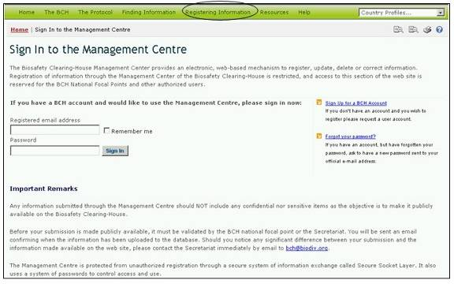
Figure 41

  - Resources

URL: http://bch.cbd.int/resources/

The Resources page of the BCH Central Portal contains sections which are meant either to help the user to interact with the Central Portal or to provide more general biosafety-related information. They are as follows:
- Common formats;
- Glossary;
- Thesaurus;
- Mailing lists;
- Solutions for National Participation
- Downloadable files;
- Online Conferences; and
- Site Map.

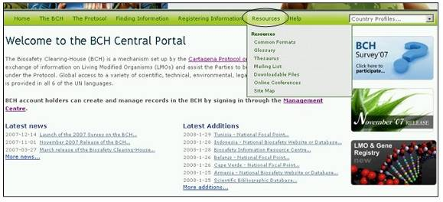
Figure 42

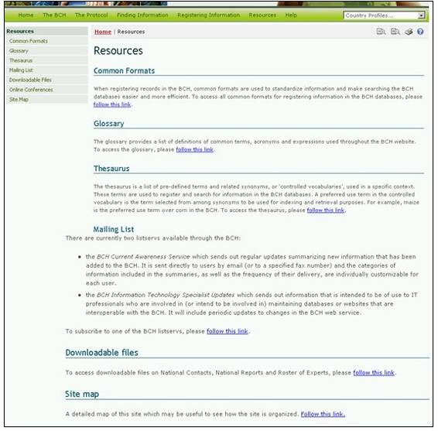
Figure 43

    - Common Formats

Common formats are provided to standardize the structure and organization of the information in the BCH databases. Use of these formats improves the efficiency of the BCH Central Portal and ensures easy and predicable access to information.
The common formats are the basis of the online entry forms in the Management Centre.

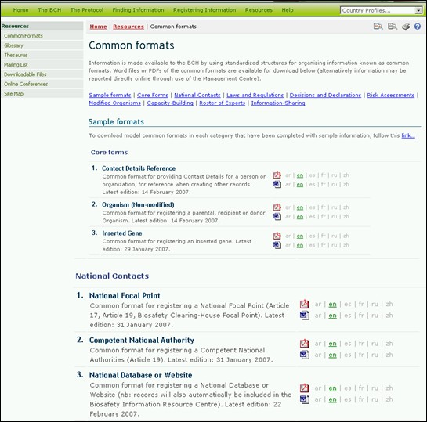
Figure 44

The Common formats page provides links to MS Word and PDF files of the common formats for the following categories of information:

- Core forms
- Contact Details Reference
- Organism (Non-modified)
- Inserted Gene
- National Contacts
- National Focal Point
- Competent National Authority
- National Database or Website
- Laws and Regulations
- National Law, Regulation or Guideline
- Bilateral, Regional or International Agreement or Arrangement
- Decisions and Declarations
- Decision on LMO under Advance Informed Agreement
- Decision on LMO FFP under Article 11
- Other Decision, Declaration or Notification
- Risk Assessments
- Risk Assessment
- Modified Organisms
- LMO – Unique Identification
- Capacity-Building Activities
- Capacity-Building Needs and Priorities
- Capacity-Building Opportunity
- Capacity-Building Project
- Academically-Accredited Biosafety Course
- Roster of Experts
- Biosafety Expert
- Report on Biosafety Expert Assignment
- Information-Sharing and Other Resources
- Biosafety Information Resource
- Biosafety Organization
- Socioeconomic Consideration

    - Glossary

The Glossary links take the user to a page which provides a list of definitions of common terms, acronyms and expressions used throughout the BCH Central Portal.
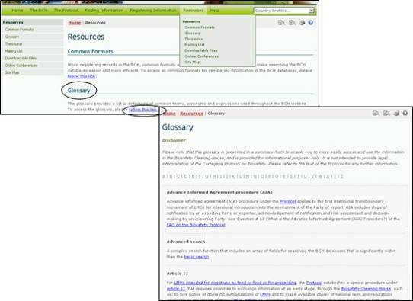
Figure 45

At the top of the Glossary page an alphabetical bar linking to sections in the Glossary is provided and descriptions of all of the Glossary terms and their use are listed in alphabetical order.

    - Thesaurus

The Thesaurus provides a list of pre-defined terms and related synonyms, or ‘controlled vocabularies’, used in a specific context. These terms are used to register and search for information in the BCH databases.

By following the link in the Resources page, the user accesses the Thesaurus Domains page, which provides on its top a search interface and below it a list of term domains in alphabetical order.
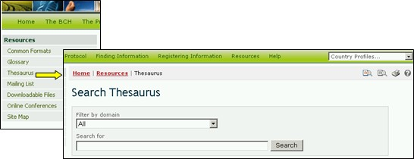
Figure 46

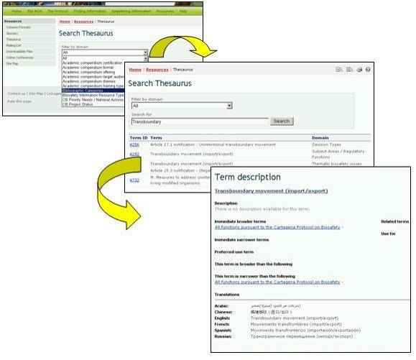
Figure 47

The Search Thesaurus interface provides a drop down menu for selection of domains within the Thesaurus and a box for use of keywords or terms in the search. The user enters the domain and/or keyword(s) of interest and selects the Search button.

In the results list, a term is selected from the Term ID column for more information about its use in the BCH Central Portal. This takes the user to the Term description record, which provides detail on the meaning of the term and how it is used in the BCH Central Portal, including broader, narrower and preferred uses of the term and translations into the six official UN languages.

Example: If a user wishes to understand the use of the term “transboundary” in activities related to the Protocol, the user enters the search terms “All” in the Filter by domain box and “transboundary” in the Search for box on the Search Thesaurus page. Selecting the Search button will provide a list of records describing how the term “transboundary” is used in various domains within the BCH Central Portal. The search results (in January 2008) identified five uses of the term in four domains within the BCH.
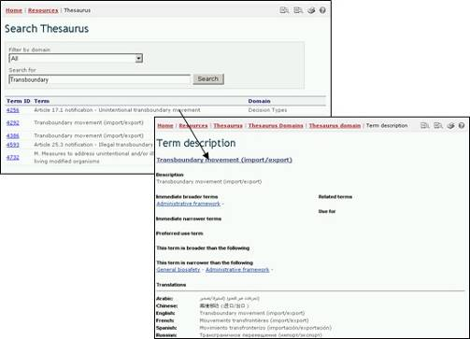
Figure 48

The list of term domains provides access to an alphabetical list of terms used in each domain. A key is provided to indicate which terms are ‘preferred’, non-preferred’ or ‘related’.

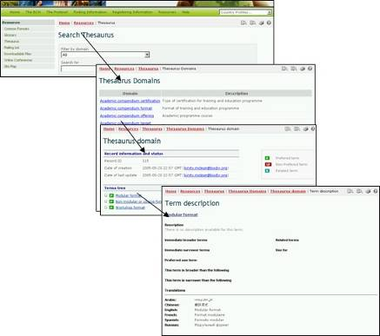
Figure 49

Selecting a term from the Terms tree list on the Thesaurus Domains page takes the user to the Term Description record. This record provides detail on the meaning of the term and how it is used in the BCH, including broader, narrower and preferred uses of the term and translations into the six official UN languages. Within a term description, the preferred use term in the controlled vocabulary is a term selected from among synonyms to be used for indexing and retrieval purposes. For example, maize is the preferred use term over corn in the BCH.

Solutions for National Participation (Hermes and the BCH Ajax Plug-In)

The Solutions for National Participation links take the user to a page which provides technical information (and links to the manuals) on Hermes and the BCH Ajax Plug-In.

Both of these solutions are aimed toward improving the ease of accessing information in the BCH in response to identified needs of users. They were created to assist countries developing their BCH national nodes to be interlinked and interoperable with the Central Portal.

    - Mailing List

The Mailing List provides access to the listservs that are available through the BCH Central Portal. Listservs are lists of e-mailing addresses for people who have signed up to receive regular information about a particular topic.

The BCH Current Awareness Service sends out regular updates summarizing new information that has been added to the BCH. While it is sent directly to users by e-mail, it is also possible to receive the updates by fax (please contact the Secretariat to enlist your fax number for this service).

The categories of information included in the current awareness summaries, as well as the frequency of their delivery, may be individually customized by each user.

The BCH Information Technology Specialist Updates sends out information that is intended to be of use to IT professionals who are involved in maintaining databases or websites that are interoperable with the BCH. It includes updates on changes to the BCH web service.

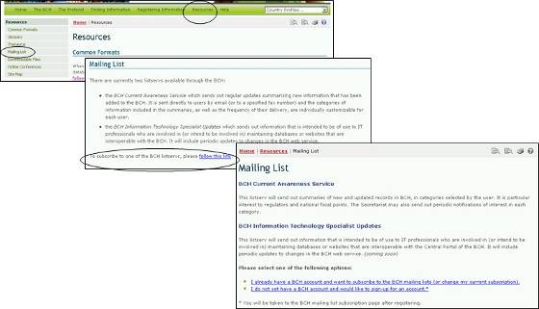
Figure 50

The Mailing List page also provides links to subscribe to the available services or to manage/update user’s subscriptions.
The first link takes the user to the Sign In to the Management Centre page. Once signed into the Management Centre the user may subscribe to a listserv.

The second link opens the Sign Up for a BCH Account page. Users register according to their affiliation with the BCH (e.g. BCH National Focal Point, Capacity-building Organization, Biosafety Expert, etc.)

Details on using the Management Centre are provided in Module MO06A.
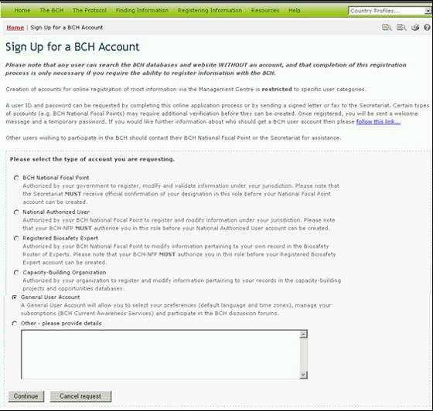
Figure 51

    - Downloadable files

The Downloadable Files page provides access to files designed to help Parties fulfill their responsibilities with respect to the Protocol’s information and reporting requirements. It also provides links to guidelines and templates for entering information. The downloadable files are available in MS Word and PDF format in the six official United Nations languages and are grouped as follows:

- Forms
- Biosafety Documents
- List of Competent National Authorities and National Focal Point Lists (updated daily)
- Roster of Experts Reports (updated daily) and summary statistics

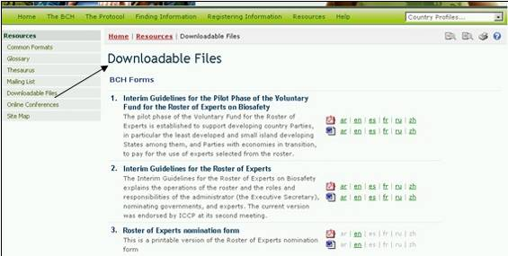
Figure 52

    - Online Conferences

The Online Conferences page provides access to the ongoing online conferences managed by the Secretariat. These conferences are organized to provide discussion and consultation platforms for Parties and interested stakeholders on specific aspects of the Protocol and its implementation.

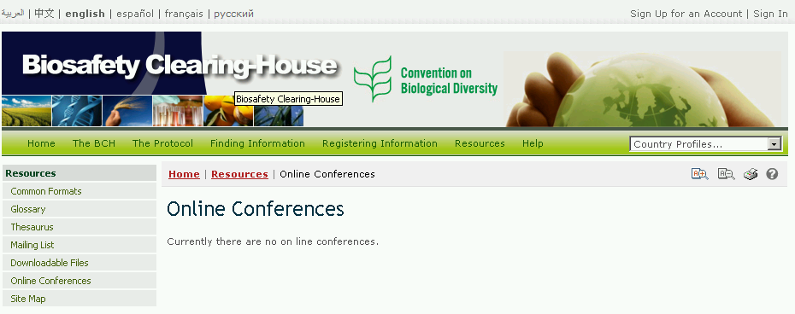
Figure 53

    - Site Map

A detailed Site Map is provided to show how the BCH Central Portal is organized.
A key identifies information categories that can be accessed via a searchable database and information that can be accessed only by a registered user.
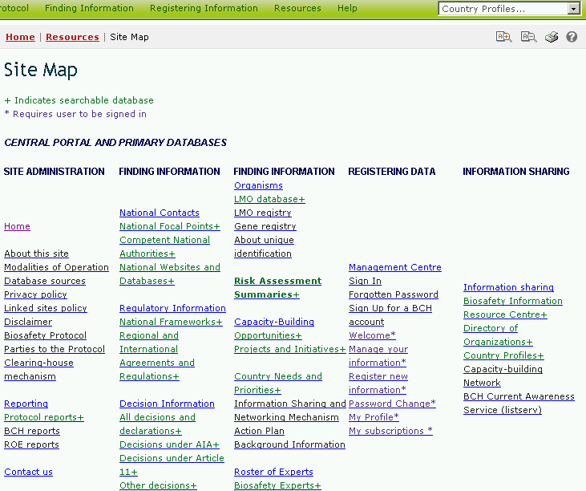
Figure 54

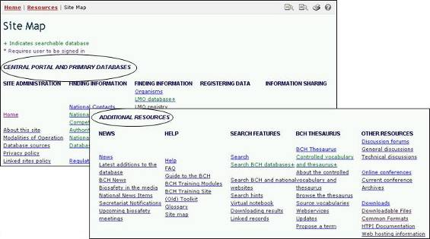
Figure 55

  - Help

URL: http://bch.cbd.int/help/

The Help page of the BCH Central Portal guides the user to five sections that provide assistance:
- Frequently Asked Questions (FAQ) about the BCH;
- BCH Training Modules;
- Guide to the BCH (brochure);
- BCH Training Site;
- Interoperability Services Documentation.
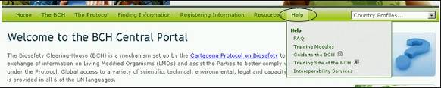
Figure 56

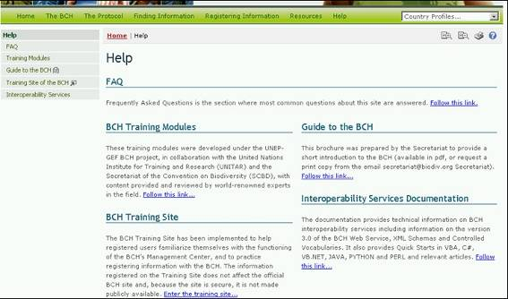
Figure 57

    - FAQ

The Frequently Asked Questions (FAQ) page lists the answers to commonly asked questions regarding the BCH. The answers provide links to articles in the Protocol and to other information available through the BCH.

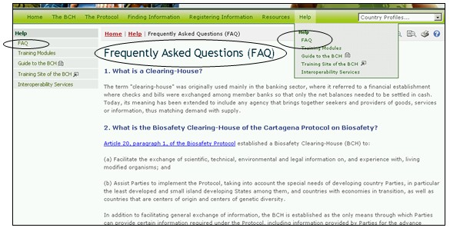
Figure 58

    - Training Modules

The BCH Training Modules were developed under the UNEP-GEF BCH project, in collaboration with the United Nations Institute for Training and Research (UNITAR) and the Secretariat of the Convention on Biodiversity (SCBD). The content was provided and reviewed by world-renowned experts in the field.

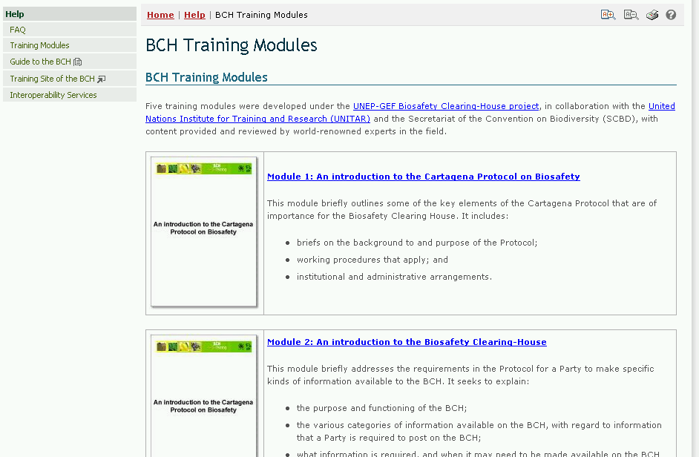
Figure 59

The Training Modules are provided in three formats:
- The BCH Training Modules;
- The Interactive BCH Training Modules; and
- The UNEP-GEF Training Workshop Manual

The BCH Training Modules consist of five modules that provide an introduction to:
- The Cartagena Protocol on Biosafety;
- The Biosafety Clearing House;
- The BCH Central Portal;
- Finding Information from the BCH Central Portal; and
- Registering Data in the BCH Central Portal

The Interactive BCH Training Modules are designed to be used in conjunction with the UNEP-GEF training manual to train participants during workshops.

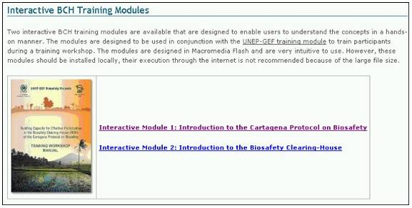
Figure 60

The UNEP-GEF Training Workshop Manual is designed to give trainers an overview of the whole training process and to provide them with insight into some of the areas that should be covered when they are conducting BCH training workshops. The complete online training workshop module provides guidelines on how a BCH training program can be conducted.

    - Guide to the BCH

The Guide to the BCH is a short brochure in PDF format that introduces the functions of the BCH.

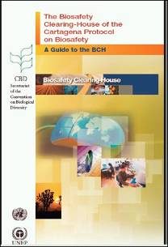
Figure 61

    - Training Site of the BCH

The Training Site of the BCH is designed to help BCH users familiarize themselves with the functioning of the Management Center without affecting the official BCH Central Portal.

In order to access the Training Site, users require BCH training accounts (which are provided upon request to the Secretariat).

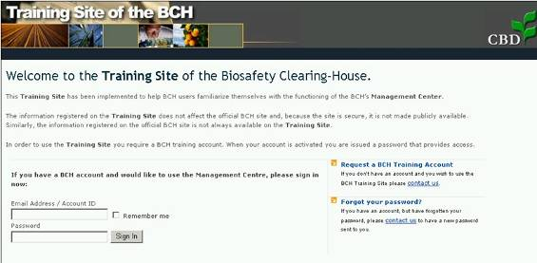
Figure 62

The sign in page provides three additional, useful links for:

- Opening a training account
- Obtaining a reminder about a password
- Access to the official BCH site.
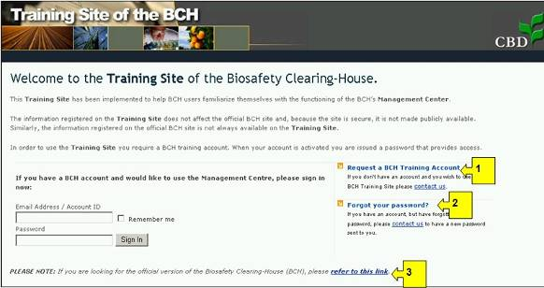
Figure 63

    - Interoperability Services

The BCH Interoperability Services documentation provides technical information about interoperability with the BCH including information about version 3.0 of the BCH Web Service, XML Schemas and Controlled Vocabularies. It also provides Quick Starts in VBA, C4, VB.NET, JAVA, PYTHON and PERL and relevant articles.

The page provides links to Quick Starts; XML Schemas and Web Service Methods.
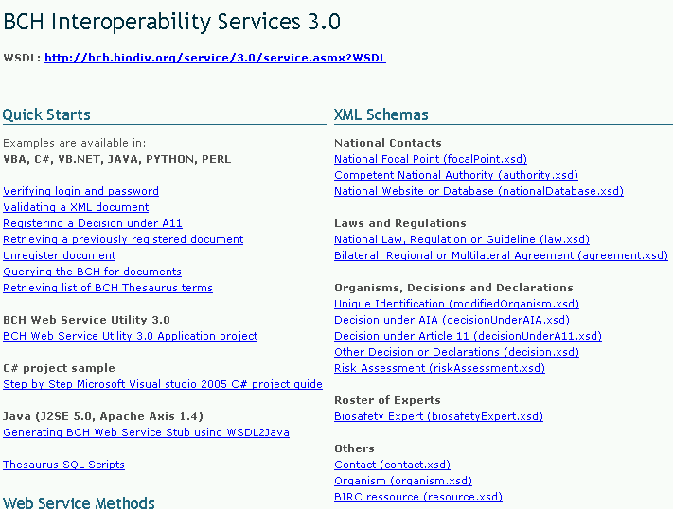
Figure 64

  - Managing Search Results

    - Sorting results

To change how the results of a search are sorted, the user can select one of the options from the drop-down menu, Sort results by, that appears at the top of any search results page. The list of options will include only those options that are relevant to the type of search the user has conducted.
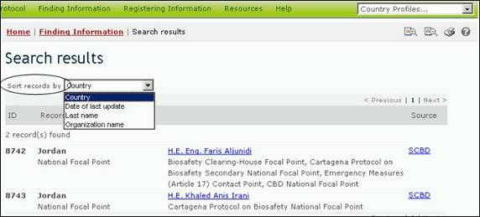
Figure 65

The sorting options that may be available to users include the following:

Country: Displays search results alphabetically by country name;

Date of last update: Displays search results by the date they were added or updated, with the most recently modified records appearing first;

Last name: Displays search results alphabetically by last name of the person or contact point;

LMO trait: Displays search results alphabetically by introduced trait or characteristic. (For a full list of introduced traits, see the ‘LMO traits’ domain in the BCH Thesaurus);

Name of the gene: Displays search results alphabetically by name of the inserted gene. (For a full list and description of inserted genes, see the Gene Registry);

Organism name: Displays search results alphabetically by name of the parental, recipient or donor organism (For a full list and description of organisms in the BCH, see the Organisms Registry);

Organization name: Displays search results alphabetically by name of the organization (organizations may include competent national authorities or biosafety organizations);

Start date: Displays search results by the date on which capacity-building projects or opportunities will start;

Subject area: Displays search results grouped according to the subject area addressed (e.g.. type of LMO, or intended use);

Taxonomic status: Displays search results alphabetically according to the scientific name of the organism;

Technique used: Displays search results alphabetically by the technique used to introduce the modification;

Title: Displays search results alphabetically by the title of the record;

Type of record: Displays search results grouped according to the type of record;

Unique identification: Displays search results alpha-numerically by the unique identification code. (For a full list and description of unique identification codes, see the LMOs-UIds Registry.)

    - Exporting results to XML

The user can export or download information from the BCH Central Portal to use in other applications by using the Export Results function. The exported information is provided in Extensible Markup Language (XML) format, a general-purpose specification for creating custom markup languages. Its primary purpose is to facilitate the sharing of data across different systems, particularly systems connected via the Internet.

The export facility is found at the bottom of each Search results page and each record. The user can select the Export Results function to export either individual records or the results of a database search. These results can be imported into another program such as a word processor or spreadsheet.
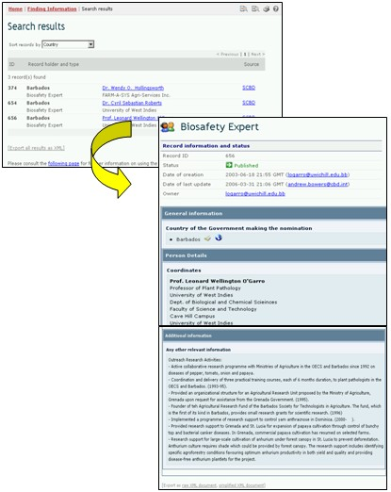
Figure 66

END

